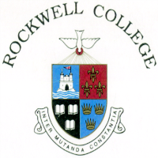
Rockwell College Scholarship Examination 2023 Entry Form
I wish to register the following pupil for the Rockwell College Scholarship examination
Name of Pupil: _________________________________ (Block Capitals)
Address: ____________________________________________
_____________________________________________
Eircode: ____________________________
Contact Number Home: ____________________________ Mobile: ___________________
Date of Birth: ______________________________
Present Primary School : ____________________________
Primary School Address : ____________________________
Signed: _____________________________________ (Parent/Guardian)
Name: ______________________________________ (Block Capitals)
⃝ I understand that if my child is awarded the Scholarship, this information will be shared with his/her Primary School Principal.

THE SCHOLARSHIP EXAMINATION WILL TAKE PLACE FROM 5:30pm to 8pm ON WEDNESDAY FEBRUARY 22nd AT ROCKWELL COLLEGE.
PLEASE ARRIVE FROM 5PM TO THE MAIN HALL VIA RECEPTION.
THIS REGISTRATION FORM IS REQUIRED FROM ALL PARTICIPANTS AND MUST BE SUBMITTED TO THE REGISTRATION DESK ON THE MORNING OF THE EXAM.
PLEASE DO NOT POST IN ADVANCE.
A fee of €50 applies to all candidates for the Scholarship Exam. This fee is deducted from the school fees of candidates who enrol in First Year at Rockwell College.
€50 cash, cheque or card accepted on February 22nd. Thank you.

