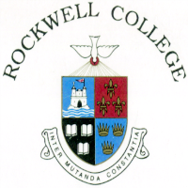
Notification regarding the Board of Management’s review of the Child Safeguarding Statement

To: Rockwell College Parents’ Association Committee

The Board of Management of Rockwell College wishes to inform you that:

• The Board of Management’s annual review of the school’s Child Safeguarding Statement was completed at the Board meeting of May 27th 2021

• This review was conducted in accordance with the “Checklist for Review of the Child Safeguarding Statement” published on the Department’s ‘website www.education.ie

Signed Damien Kennedy Date May 27th 2021
Chairperson, Board of Management

Signed Audrey O’Byrne Date: May 27th 2021
Principal/Secretary to the Board of Management

