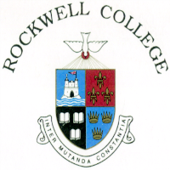
ROCKWELL COLLEGE
ANNUAL ADMISSION NOTICE FOR 2022/23

Copies of the school’s Admission Policy and the Application Form for Admission for the 2022/23 school year are available as follows: –
To download at: www.rockwellcollege.ie
On request: By emailing info@rockwellcollege.ie or writing to: Rockwell College, Cashel, Co. Tipperary E25 ED60

- Application and Decision Dates for admission to 1st Year for 2022/23
1. | The school will commence accepting applications for admission on | 4th October 2021
2. | The school will cease accepting applications for  admission on | 5th November 2021
3. | Applicants will be notified in writing of the decision on their application by | 26th November 2021
4. | Applicants must confirm acceptance of an offer of admission by | 14th January 2022

Failure by an applicant to accept an offer by the 14th of January 2022 may result in the offer being withdrawn.

- Number of places being made available in the 2022/23 school year
The number of places being made available in 1st year is | 96
The number of residential places is (boarding schools only) | 18
The number of non-residential places is (boarding schools only) | 78

- Number of places in 1st year for the 2022/23 school year which were offered and accepted before 1 February 2020
The number of places for 1st year that were offered and accepted prior to the coming into operation of section 62 of the Education (Admission to Schools) Act 2018 on 1 February 2021 is | 1

