Rockwell College
Boarders Information Handbook
2020-2021



MISSION STATEMENT
Rockwell College is a Catholic, co-educational school, where boys and girls can grow and develop in a caring and supportive atmosphere. The pupil body comprises boarders and day-boarders educated in the Spiritan tradition. The College operates under the trusteeship of the Des Places Educational Association.
We support the principles of providing an environment where Catholic Values and practices are promoted and maintained, pupils can develop their full potential, personal responsibility is promoted, life-skills are reinforced through participation in educational, sporting and cultural activities, pupils are prepared for an appropriate career, pupils are made aware of their cultural heritage, parental collaboration is promoted and encouraged, an education free from fear and intimidation is provided, a sense of integrity is nurtured, and the student demonstrates respect of values, diversity of tradition, language and ways of life in society. This will be fostered through the pastoral care system of the college.
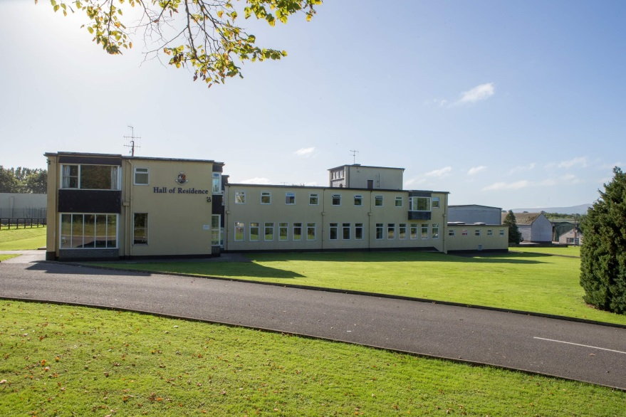

Manager’s Welcome
Welcome to Rockwell College, where we offer residential accommodation for boys and girls on a 7day and 5 day basis. Girls are catered for in locally based host families, while up to 130 boys board on-site in Shanahan Hall.
Pupils from all corners of Ireland and from around the world choose Rockwell College for their second-level education. Our pupils come from U.K, France, Germany, Spain, Russia, U.S.A, Japan, Hong Kong, South Korea, and Dubai. This diversity of cultures creates a unique environment for all pupils attending the College, and is part of the College ethos of inclusivity.
As a boarder in Rockwell College, you will experience a well-structured environment that promotes academic and social development in the Spiritan tradition.
Our boarding facilities are spacious and modern, providing a comfortable and high quality living space. Facilities are upgraded annually. We hope boarders will feel that Shanahan Hall is their home while they are with us.
Boarders will develop their independence and their sense of responsibility within the care and protection of the College staff.
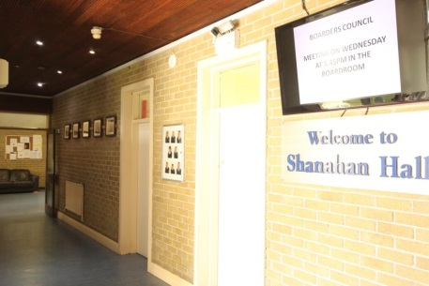
I look forward to welcoming you here.
Deirdre O'Connor
Residence Manager

Handbook Contents
Section 1: Residence Information
- Contact Information
- List of Staff
- Daily Schedule
- Boarders Leadership
- Transport & travel
- Permission to Leave
- Pocket Money
- Boarders Weekends
- Laundry
- Lost & Found
- What to bring

Section 2: College Information
- Book Lists
- Change of Details
- Dining
- Activities & Extra curricular
- Website
- Policy Documents
- Health Centre
- Medication
- Pastoral Care & support
- Residence Code of Behaviour
- Suspension and Expulsion Procedures

Contact Information
For school, Year Dean and/or finance related queries
Rockwell College Reception & Administration
Monday to Friday 8:30am to 18:00
Phone: +353 62 61444
Email: info@rockwellcollege.ie

Reception: Ms Nicola Cleary
Admissions Secretary: Ms Jeanette Hickey
Principal’s Secretary: Ms Eileen McCormack
Finance Manager: Ms Joan Kennedy
Accounts Secretary: Ms Josephine Hayes
accounts@rockwellcollege.ie
Contact reception to access:
Principal: Ms Audrey O’Byrne
Deputy Principal: TBA
Health Centre: Nurse Mary-Rose Ryan
Nurse Sabrina Moore
Year Deans

Website: www.rockwellcollege.ie
Twitter: @rockwellcollege
Linkedin: Rockwell College
College
Rockwell College Residence
For Boarding related queries
Residence can be contacted via reception as above.
Residence Manager: Ms Deirdre O’Connor
Residence Office: +353 62 64184
Residence Mobile: +353 87 387 8677
Residence email: residence@rockwellcollege.ie
List of staff
House Staff 2019-2020
Residence Manager | Ms Deirdre O’Connor
Senior Deans | Mr Eoghan Anderson  Mr Conor Cashman  Mr Kevin Leamy  Mr Kevin O’Hora

Daily Schedule
- 7:30am Rise & Shower
- 8 am. Breakfast for all
- 8:40am Assembly for all pupils
- 8:50am Class (with ten minute break at 10.50 and lunch at 13.00).
- 3.45pm Class finishes
- 4 pm Sports and extra-curricular activities.
- 5 pm. Tea (all pupils).
- 5:45pm Study (all pupils).
- 8:15pm Supper.
- 8:30pm Boarders’ Study
- 9:15 pm Return to Residence.
- 10:30 pm Lights out.

Weekends in Shanahan Hall
Weekends are somewhat less structured, giving 7 day boarders some much needed rest. However, routine is important, and there are activities organised for boarders who wish to take part.
Saturday study is compulsory for 2nd to 6th year and optional for first years from 10am to 12pm. Overseas students attend English Language classes. A trip to the local town occupies the afternoon.
Boarders can take part in games and leagues organised by residence staff over the weekends in soccer, pool, table football. Alternatively, there is a supervised boarders swim on Saturday evening, and a selection of board games available freely in the common room.
On Sunday morning, all boarders attend mass. Once a month, trips and excursions are organised regularly throughout the year to entertain our boarders and to give them an opportunity to see some local and national history and culture. Sample excursions include Cahir Castle, Mitchelstown caves, Kilkenny Castle as well as paint-balling, karting, ice-skating and bowling. These fees are charged separately to the reserve account. Costs are kept as low as possible, and we encourage all boarders to go.
Saturday
- 8:30am Rise & Shower
- 9:00am Breakfast for all
- 10am-12pm Study for 2nd, 3rd, 5th & 6th
- Cambridge Exam Classes
- Computers 4th year
- 12:45pm Lunch
- 1:15pm Supervised visit to Clonmel
- 5:00pm Tea
- 7:30pm Boarders swim
- 9:00pm Movie in Cinema room
- 11:00pm Lights out
Sunday
- 10:30am Mass for all
- Optional study available
- 12.45: Lunch
- 1.30pm Sports and Games
- 5pm Tea
- 8pm 5 day boarders return
- 10.30pm Lights out
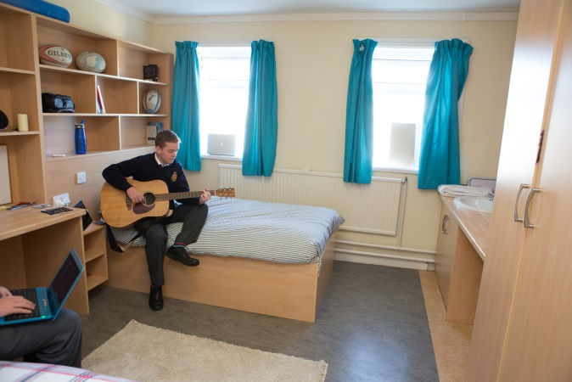
Sunday trips are organised on a monthly basis for 7 day boarders

Prefects
Boarders who display leadership qualities are chosen for this role, and given areas of responsibility. Prefects take a pastoral role with younger boarders, promote the spirit of Rockwell College, and give guidance. They encourage and remind boarders about respecting the Code of Behaviour. They link boarders and staff where needed.

Boarders Council
The Council is made up of representative boarders from every year group and meets on a monthly basis with the Residence Manager. Boarders are nominated onto the council by their peers at the start of the year, and are expected to regularly chat with each other so that they can bring any suggestions or issues to the council meetings to be discussed.
This is an opportunity for the boarders to discuss with staff any suggestions or thoughts they have for boarding. We value the input of all our boarders in the day to day running of the house. The Boarders Council ensures that their opinions are valued and listened to.

Student Induction
All boarders attending Rockwell College will be given a full induction, which will include much of the information given here, in addition to the rules and regulations in operation in the residence.
Transport
Rockwell College has the benefits of being in a rural location, while being accessible to many towns with bus and train connections throughout the country. We will arrange transport at weekends to scheduled buses and trains which depart from local towns. Please contact the Residence Manager to arrange transport needs for your son or daughter at the start of the academic year. Where we cannot provide transport, we can arrange for a local, reputable taxi company, which will be charged to your reserve fee account. Parents who book a transport package at the beginning of the year, will receive a discount. The package can be booked as follows via the residence manager:
5 day boarders transfer Package
Each weekend, mid-term breaks and school holidays
- Minibus to and from Thurles train station €300
- College car to and from Cahir/Cashel bus stop €150
7 day boarders transfer package:
Boarders’ weekends, mid- term breaks and school holidays
- Minibus to and from Thurles train station €100
- Include Saturday bus to Clonmel €150
- College car to and from Cahir/ Cashel bus stop €50
- Include Saturday bus to Clonmel €100
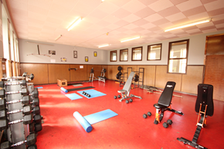
Holidays and Mid Term travel
Flights must be booked on the dates advised, and within the hours as set out, in order to avail of College transfers. Overseas students return home for school holidays.
Minors travelling overseas alone may need to be accompanied through check-in. This is airline dependant and parents must notify the Residence Manager if this is required. Minors can only be accompanied by staff on the designated dates and times.
Overseas students travel is the responsibility of the agent or guardian.

Permission to leave
In the interest of the safety and welfare of all boarders, no boarder may leave the grounds without permission. To do so is regarded as a serious breach of discipline. Anyone wishing to leave must have permission from the Senior Dean on duty. This will only be if parental approval has been received in writing.
Permission to leave with parents is also required for:
- Sunday outings after mass.
- Visits home on Saturday.
- Visits out after school or for special occasions.
All requests for permission to leave must be made to the Residence Dean on duty, and expected return time must be given.
Students leaving the College grounds must be signed out to the care of a parent or adult. If leaving during the school day, the student is signed out at the main College Reception. Outside of school hours, the student is signed out from the Residence. Where a seven day boarder is permitted to leave overnight, they must not return to the college prior to the agreed time.

Pocket Money
Overseas boarders can avail of a pocket money account. Parents will be given the account number into which the desired amount can be lodged for the term. Money can then be withdrawn by boarders on specific days. Boarders will not be permitted to withdraw money that is not lodged and cleared through their account. If boarders have pocket money remaining at the end of the year, this will be returned to the students.
Boarders Weekends
Approximately every three weeks the Residence closes for a Boarders’ Weekend. Irish residents return home for this weekend and our overseas students are accommodated by local Host Families.
School closes at 3.45pm on Friday evening, and boarders may return after 6pm on the Sunday evening.
Laundry
The laundry service is located in the Residence and is available Monday to Friday. Boarders need to become accustomed to managing their own clothes, ie, choosing clean clothes each day and putting soiled clothes into their laundry bag. They need to be aware of their responsibility to collect their laundry at the pick-up point.
A large laundry load costs €20 to wash, dry and iron, and is charged to the reserve fee account
Note: All clothes must be marked with the student’s name. No responsibility will be taken for unmarked clothes.
Boarding students are urged to use the school laundry for their clothing, both for hygiene reasons, and to maintain tidiness in the dormitories.
Every boarder is required to have and use a laundry bag/ basket in their room. Any item requiring special attention (eg, wool, delicate) needs to be brought personally to the laundry service, and not included in the laundry bag with general washing.

Lost & Found
There is a lost and found in the Residence laundry, students should check there for any missing clothing.
All unclaimed clothing will be given to charity at the end of each term.
What to Bring
Clothes and Equipment
- School Uniform
School jumper, school tie, white shirt, grey trousers and black or brown leather shoes.
Uniform available in Clintons of Clonmel and on www.clintons.ie

- Sports Kit
Students are required to wear the College sports kit for matches and travelling to away matches. The Rockwell College Sports kit is produced by Canterbury of New Zealand and supplied by Uniformity www.uniformity.ie. All items can be purchased online. Kit consists of:
- School Jersey
- Pro Shorts
- Classic 1/4zip jacket
- Track pants
- Socks
Uniformity will deliver directly to your home or alternatively orders can be delivered to Rockwell College for collection on arrival in September.
Boarders should bring runners, studded boots and their own portable equipment, ie, rackets, balls, etc.
Note: the College sports kit is not required for PE class- students own clothing is acceptable. Quality runners are required-no soft shoes.
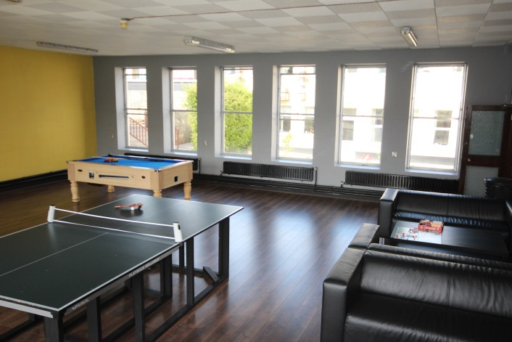
Bedding
Boarders must bring:
1 x Mattress protector
1 x duvet (Not feather)
1 x pillow
2 x duvet covers
2 x single sheets
2 x pillow cases
1 x laundry bag.
1 x net washing bag for small items
Towels

Linen supply:
The residence can supply linen for overseas students on request and subject to availability for a fee of €115. The linen package includes:
Duvet, Pillow, 2 x Sheets, 2 x Duvet covers, 2 x pillow covers, Laundry bag, Mattress protector, net washing bag
If you wish to avail of the linen supply, please notify the Residence Manager by email on residence@rockwellcollege.ie

Personal Items
Boarders must bring their own supply of shower gels, soap, shampoo, toothpaste and all other items of personal use. In addition, boarders need to bring their own towels- these can be washed in laundry with clothes, as required.

Electrical devices
Only small personal electrical devices should be brought to the Residence. TVs and Gaming consoles are not encouraged. No heating or cooking devices are permitted.
Overseas students should ensure they have the correct plug/power adapter for use in Ireland. The standard voltage is 220v. We use 3 pin fused UK plug/socket. Only original manufacturers’ chargers are permitted for safety reasons.

Dormitories
The Residence is locked between 8.30am and 3.45pm. It is open after class to allow boarders to collect their sportswear. There is strictly no access to the Residence during class hours, including break and lunchtime. Pupils who access the Residence without permission will be sanctioned under the Code of Behaviour.
Bedrooms and dorms are not locked. Students are asked not to store items of high value or cash in their rooms. All boarders should bring a bicycle lock for their wardrobe doors. Safes are available to rent for an annual charge of €10.
Boarders are expected to treat the dormitories with respect. Rooms will be inspected on a daily basis. Rooms must be neat with beds made.

Section 2 College Information
Book Lists
Book lists are issued to all students in the month of June prior to the next school year. Lists are also available to view on the Rockwell College website, under the academic tab. Please ensure you choose the correct list. Books can be ordered online at https://www.stakelumofficesupplies.ie/rockwell-college-cashel and delivered to the school. Boarders for whom Rockwell College acts as agent will have their books supplied by the school.
Change of Address/Details
Any change of address or contact details must be notified immediately to the Principal’s secretary, Ms Eileen McCormack, Email info@rockwellcollege.ie

Dining
All meals are prepared on site in our kitchens, using only the highest quality, locally sourced ingredients. Our meals are wholesome, and aim to help sustain our students day by day for success in their academic studies and sports. Boarders can have input into the menu through the boarders council.
Special dietary requirements, food allergies or intolerances should be confirmed in writing to the Admissions Office prior to the beginning of the school year. It is the responsibility of parents to ensure the information is communicated in good time to the College.
Activities & Extra Curricular
Sport in Rockwell College is an important part of a student’s development and an important avenue for integrating and making friends. We are conscious that every child is different and we hope that your child will find an extra curricular activity that he or she will like. We believe it is important to challenge each child to fulfil his or her potential and also to remain healthy and resilient for the challenges of life ahead.
Sports on offer include athletics, basketball, rugby, soccer, swimming, GAA and tennis. Some are available all year around, and others seasonally.
Facilities include 3 outdoor tennis courts, 7 rugby pitches, indoor heated 20m pool (supervised), all weather pitch and training area, a soccer pitch, sports hall and a weights/cardiovascular suite.
Non-sporting activities include debating, computers, International Relations Club, College musical and the College library
The Rockwell College Music Academy
The Academy provides lessons in a range of instruments at all levels, as well as tuition in other areas of music and drama. Lessons are booked by parents directly via the website: www.rockwellcollegemusicacademy.com
Website
The College website is www.rockwellcollege.ie
The website is a useful place to keep informed about the latest news and events in Rockwell College. The calendar section informs of fixtures and events.

Policy Documents
Rockwell College updates policy documents regularly in line with good practice and are available on the College website. Policies specific to Boarding are available under the ‘Residence’ tab, and also displayed in the reception area in the Residence
Health Centre
The health centre is accessible in the Residence and the College throughout the day. The College doctor is located at Market Yard, Cahir, Co. Tipperary, just 10 minutes from Rockwell College. Boarders will be brought to the doctor on instruction from the college nurse. Rockwell College is located 5 minutes from Cashel Hospital Minor Injuries Unit, and just 20 minutes from South Tipperary General Hospital
In addition to medical care, the nurses work closely with the Deans and chaplain in the provision of pastoral care. The nurses are always pleased to discuss any worries or concerns of parents or students.
It is the responsibility of parents to ensure that the Health Centre has your child’s most up to date medical history. Non-disclosure of any condition means that your child cannot be properly cared for.

Medication
If medication is prescribed for your child then this should be discussed with the nurse, who will ensure that it is administered correctly. The nursing staff will arrange repeat prescriptions, if required.
We keep routine medication in the Boarding House that you would expect to find in any home, e.g. Paracetamol, Ibuprofen and Piriton, that can be administered when a child is unwell. Boarding or nursing staff will administer this to a child who is unwell according to established policy.
If parent would like us to administer non-prescribed medications to their child, such as cough medicine or regular anti-histamines, then please:
- Bring in suitable medication for your child’s age
- Leave it in its original packaging
- Clearly mark it with your child’s name.
Boarders are strictly prohibited from keeping their own medication.

Residence staff members have received Emergency Medicines training, and there are strict controls in place around the management of boarders’ medical needs during the school day and in the Residence. However, Deans are not medical professionals, and will act under the instruction of the nursing staff. Best judgement may be used on occasion and in what they see as the best interest of the boarder in their care.
See the website for Administration and Handling of Medicines policy.

Pastoral Care & Support
At Rockwell College, we are very fortunate in having a large number of adults to whom students and their families may turn if they feel something needs to be sorted out or if they have any suggestions. In the Residence, boarders’ views are sought and respected, with regard to any matters relating to their lives within the school, both informally throughout the day to day contact with individual staff and more formally through discussion forums, or via the Boarders’ Council.
There may be times when a boarder feels unhappy about being away from home, or about something which has happened. If this arises, then the most important thing to stress is that they should seek out an adult with whom they feel they can discuss it.
The Deans are always available to talk if there are any concerns about general routines, or about managing life as a boarder, most of which can be quickly and smoothly resolved. The concerns may be of a more serious nature, and of course, in such cases, the Residence Manager or Principal may be consulted.
The following guidelines are displayed in the dormitories and in public areas around the Residence:
Is someone making you feel unhappy?
Do you need to talk to an adult?
Do you want to complain about something?
If you are unhappy about any issue, or the way you are treated at Rockwell College by another child or an adult, then you should speak to a grown-up who you feel you can trust.
Boarders might choose to speak to:
- The Residence Deans
- The Residence Manager
- The College Chaplain
- The Deputy Principal or Principal
- The Nursing Staff
- The Guidance Counsellor
Rockwell College supports the concept of “One Good Adult”- that every student should have an adult in the College or Residence that they can turn to. This may also be a coach, a teacher or any adult staff member that they feel comfortable speaking with.
In addition to adult support, Prefects are appointed to all year groups within the College and also within the Residence. These pupils can be a useful support and intermediary for pupils with concerns.
There may be occasions when a boarder would prefer to speak to support outside of the Residence. Contact details will be available to boarders for Childline and the Ombudsman for Children.
This is established good practice in any environment where children are resident.

Childline
By phone 24 hours a day: 1800 66 66 66
One to One live chat 10am-4am every day: www.childline.ie
Text 10am-4am daily: Text ‘Talk to 50101
Text ‘Bully’ to 50101
Text ‘Help’ to 50101

Ombudsman for Children
Phone: 01 865 6800
Ombudsman for Children’s Office
Millennium House
52-56 Great Strand Street, Dublin 1
DO1 F5P8
Email oco@oco.ie
These contacts will be posted in good faith and to support pupils.
Rockwell College will regard it as a serious breach of conduct if any pupil knowingly engages in malicious or erroneous contact with the above.

Residence Code of Behaviour
Rockwell College recognises that boarding students will, on the whole, adhere to the expectations of the Residence in relation to positive behaviour. The following are examples of the behaviour expected of all boarding pupils. Breaches of this behaviour will result in sanctions being applied.

Expected Behaviour:
- Punctual Arrival to Breakfast/Study as directed by staff.
- Respecting the peace and privacy of other boarders in their rooms.
- Punctual attendance to Detention.
- Presenting oneself properly for school or other events, including Mass.
- The avoidance of Littering
- Following all staff / Dean Instructions.
- Demonstrating full respect for staff members or for fellow students.
- Responsible and age-appropriate use of internet facilities.
- Respect for others’ property and the avoidance of Stealing and/or engaging in deception/misleading behaviour .
- Consistent good behaviour.
- Avoiding use of abusive/offensive language.
- Respect for property and avoiding Vandalism/defacing school property.
- Under no circumstances is the accessing, possession and/or distribution of pornographic material tolerated.
Health and Safety:
Rockwell College Residence adheres to good practise in relation to general Health and Safety concerns. Boarders are expected to act positively to ensure a high level of Health and Safety. For clarification, boarders should note that a boarder is in breach of Health and Safety Regulations for:
- Not keeping the bedrooms reasonably tidy and clean.
- Use of Mobile phone or other personal electronic equipment after lights out .
- Possession of/distribution of/under the influence of Drugs.
- Possession of/distribution of /under the influence of Alcohol .
- Possession of/use of items designed to cause injury or harm.
- Smoking (including vaping).
- Behaviour liable to cause injury or damage.
- Bullying (including cyber bullying).
- Physical violence.
- Breach of Fire Safety precautions.

Sanctions

Scale of Sanctions
While it is hoped that sanctions will not have to be used in relation to a pupil’s behaviour, the following will all be considered in line with the above statement

- Recording in Incident Book
- Verbal guidance on improvement of behaviour
- Verbal caution
- Referral to Residence Manager
- Restricted access to Residence
- Confiscation of phones/technology
- Detention – on a single or repeated basis
- Community Service
- Removal from an activity or trip
- Communication with parents
- Suspension from Residence
- Expulsion from Residence

All sanctions will be administered with due regard for the principles of fairness and natural justice and with consideration of the rights and responsibilities of all parties.

Suspension & Expulsion Procedures
Introduction
The suspension and expulsion procedures of Rockwell College Residence are formulated in conjunction with the Code of Behaviour of Rockwell College Residence. The purpose of this document is to outline the school’s approach in instances of Suspension or Expulsion, and has been formulated taking due consideration of the principles of fairness and natural justice.
Definitions:
Boarder- any boarder registered as a boarder with the College.
Parents- parents/guardians/agents of registered boarders
Suspension is defined as ‘requiring the student to absent himself/herself from the Residence for a specified, limited number of days’.
Expulsion is defined as ‘a decision to permanently exclude a boarder from the Residence’
It is the aim of Rockwell College that boarders would recognise the consequence of unacceptable behaviour and that this understanding would limit instances of poor behaviour. However, it is recognised that instances can take place that will require the removal of boarders on a temporary or permanent basis.
Objectives
This document is intended
- To ensure that the principles of fairness and natural justice are adhered to.
- To ensure that there is a clear understanding of how the college will approach instances of suspension or expulsion.
Decision to Suspend or Expel
- Suspension or Expulsion will be considered as a sanction in instances when:
- A boarder’s behaviour is having a detrimental effect on the education, behaviour or comfort and ease of other boarders.
- A boarder’s presence in the residence constitutes a threat to the safety to boarders or staff.
- A boarder has engaged in serious damage to property.
- A boarder’s possession of that which may constitute a threat to safety including (but not limited to) legal or illegal substances or weapons.

This list is not exhaustive. The responsibility of College management is the protection of boarders’ safety and welfare, therefore boarders who impact on that in ways not listed above may be liable to suspension or expulsion.

